Waterbeach Community Primary School

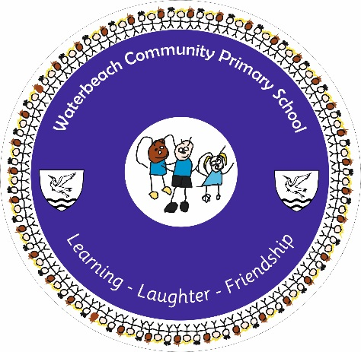

Guidance for Parents/Carers
First Aid & Medicine
In School
Policy

FIRST AID - INFORMATION FOR PARENTS/CARERS

ROLES AND RESPONSIBILITIES

It is the Parent/Carer’s responsibility:
- To provide school with up to date contact details and medical information for their child and update these as necessary.
- Follow school guidance on what foods are allowed to be brought into school to minimise the risk of a child with an allergy suffering an allergic reaction.
- To inform the school of any prescribed antiobiotics/medication to allow monitoring of the child in case of any adverse reaction.
- To ensure that if their child has a severe medical condition they provide a protocol, including signs and symptoms from the child’s GP or hospital consultant. This is required before staff can give any medication in school.
- To supply all medication in the original packaging and hand it into the office.
- To ensure the packaging is clearly labelled with the pupil’s name and date of birth and the time and frequency that the medication should be given.
- To replace medication before it expires and to dispose of any expired medication.
- To notify the school of any changes – preferably in writing from the child’s GP or hospital consultant.
- To collect any medication at the end of the school year otherwise it will be destroyed, with the exception of in-date Epipens and inhalers.
- To ensure that their son/daughter does not carry any medication on themselves.

It is the School’s responsibility:

- To ensure adequate first aid provision including suitably trained staff and first aid equipment is available at all times.
- To administer medication to the pupil or supervise while he/she takes his/her medication according to predetermined protocol only.
- To record all medication taken by pupils (date, time, medication, pupil and staff member).
- To ensure that all medication is in date before issue.
- To destroy any medication left in school at the end of a school year or when a child leaves.
- To maintain the safety of all medications in a locked but accessible area.
- To ensure that all staff are trained as appropriate.
- To contact parents/carers, if required, when a child is hurt, needs medical treatment or feels unwell.

FIRST AID PROVISION
The school has carried out and regularly reviews the First Aid Risk Assessment to ensure that adequate first aid provision is available at all times. All First Aiders have attended a recognised First Aid Course approved by the Health and Safety Executive (HSE) and attend refresher courses every 3 years.
There will always be at least one Named First Aider and several Emergency First Aid at Work trained First Aiders. A First Aider is present in each playground at playtime and lunchtime and they will have a First Aid box to administer basic First Aid in situ. If it is a more complex situation the child will be escorted to the School First Aid station near the School Office.

There will always be at least one First Aider on a school trip, village walk or other activities outside of school with a First Aid bag. On a school trip, village walk, when swimming and during any other activity outside of school the First Aider will take all children’s emergency prescribed medication.
There will always be a Paediatric First Aid trained person on the school site and available for Early Years Foundation Stage at all times, including trips.
Record Keeping and Passing on Information
All first aid incidents/complaints are recorded in a treatment book – located in the medical room, at the medical stations or in the first aid boxes/bags with details of name, date, time, nature of injury/complaint, treatment given/no treatment given, and initials of the first aiders/s. The class teacher is informed of any injury and any child with a head injury will be given a wrist band – as well as a slip. Parents/carers will be informed of any significant injury and all head injuries. Equally if your child has had an accident at home you should inform school.

What to do if your child is unwell…
Please call the school office as soon as possible to inform us of the reason for your child’s absence and do this every day that they are not able to attend. If we do not receive a message we will call you to ask why they are not in school. If there is no response it may be necessary to visit the home address in order to ascertain the whereabouts of your child.
Sickness and Diarrhoea
If a child has been sick or suffered from diarrhoea, they will be sent home from school/should stay off school. They should not return to school until 48 hours after the last symptoms of sickness and diarrhoea.

Contagious Conditions
Advice should be sought from guidance documents and health care professionals to minimise the spread of contagious conditions. If you are unsure, contact school for advice.

Managing Medical Conditions and Medicines
Our school is committed to working with the parents and carers of children who have medical requirements, medical practitioners and other appropriately involved agencies to meet children’s needs and to enable children to access education wherever possible.

Medicine in our School
Prescribed medicines should only be brought into school when essential: that is, where it would be detrimental to a child’s health if the medicine were not administered during the school day. Where possible, parents/carers are asked to administer their children’s medicines at home. Most medication can be given three times a day; before school, after school and at bedtime.

If a child is well enough to remain in school but has been prescribed antibiotics requiring administration during the school day we advise that a parent/carer comes into school to administer the medication.

Medicines allowed in School:
If a child/employee starts at Waterbeach Primary School and has a medical condition that is potentially life threatening, a medical protocol will be put in place. This must be informed by a Health Care Plan or advice from the child’s GP or Hospital consultant and will be written in conjunction with parents/carers. School will review medical protocols annually or sooner if the needs/condition changes. Parents/carers are responsible for informing school of any changes.

Our school will store and administer, with relevant training, medication for the following conditions:
Allergies requiring an Epipen, Diabetes, Asthma (See Asthma and Emergency Inhaler Policy), ADD/ADHD, other long term conditions agreed with Headteacher and First Aid Coordinator.

Allergies – measures to reduce the risk of allergies.
- We aim to minimise the risk of any child suffering from allergy induced anaphylaxis whilst in school. Clear medical protocols will be written as outlined above.
- Where necessary school will request that food brought into school is free from any allergens that could trigger a child’s anaphylaxis. School will regularly remind parents and where necessary monitor the contents of snack/lunches.
- The school catering provider will be informed of any allergies and steps will be taken to minimise the risk.
- At events held on school premises (e.g. charity events) the school cannot be held responsible for food items not produced in school and cannot guarantee they are free from allergens. It is left to the discretion of those purchasing to determine the potential for allergens to be present and accept any risks.

PE Safety
No jewellery should be worn during Physical Education lessons including swimming. It is also not safe to cover earrings / studs / sleepers with tape. If children wear earrings to school they need to be able to remove them themselves for PE lessons. If your child is unable to do so, earrings should be removed before coming to school. We advise that if you are going to allow your child to have their ears pierced, that this is done at the start of the summer holidays so that their PE entitlement is not compromised.

The information in this leaflet is drawn from the school policy ‘First Aid and Medicine Management’ – The full policy is available from the school website or a paper copy can be requested from the school office.

